# CHAPTER-5 TECHNICAL SPECIFICATION

* 1. **Hardware Specification:**
* **5.1.1 Ram :** 2 GB
* **5.1.2 Hard drive Storage Needed ( Desktop ) : 100**GB
* **5.1.3 Hard drive Storage Needed ( Mobile Phone ) : 10**GB

# Platform:

* **5.2.1 Supported Operating System:** Windows XP and above LINUX and MacOS is compatible.
* **5.2.2 Programmer Server:** Apache Server 2.2.

# Framework:

* **5.3.1 Mark-up Language:** HTML4 and HTML5.
* **5.3.2 Programming Language:** PHP 5.3

# Technical Specification:

* **5.4.1 Front-End:** PHP 5.3
* **5.4.2 Back-End:** MySQL 5.5.24
* **IDE Tools:** Sublime Text3 and Marco Media Dreamweaver.
* **UML Tools:** Microsoft Office Visio 2007
* **SRS Tools:** Microsoft Word 2016.

# DESIGN LAYOUT Homepage:-



**[Figure 8: Homepage Top]**

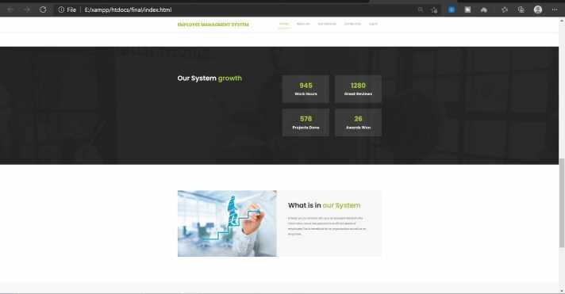

**[Figure : Homepage bottom]**

# ADMIN:-

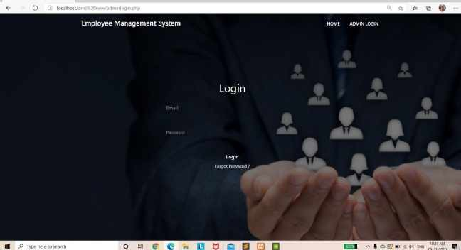

**[Figure : login page]**

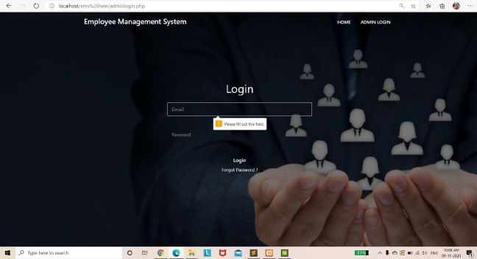

**[Figure : login page validation]**

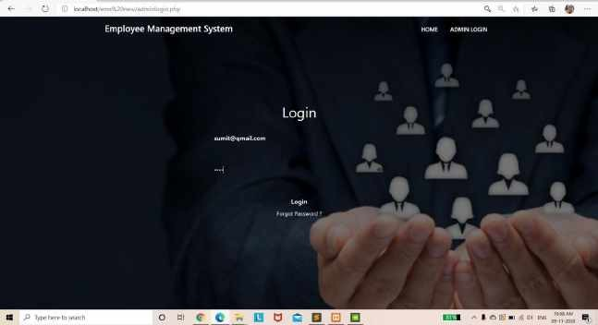

**[Figure : login page with detail]**

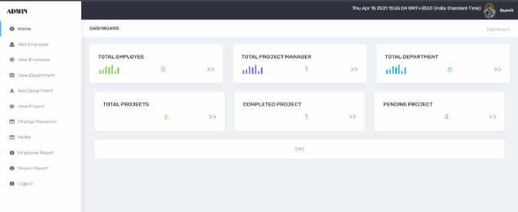

**[Figure : home page]**

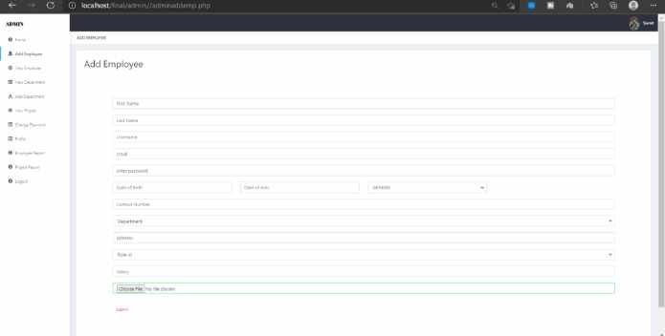

**[Figure : add employee]**

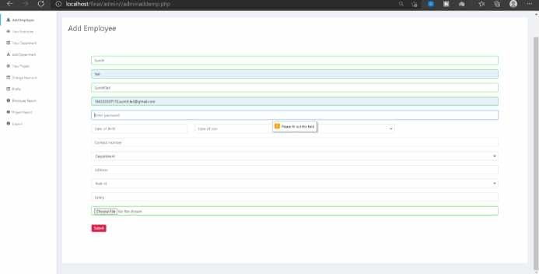

**[Figure : add employee validation]**

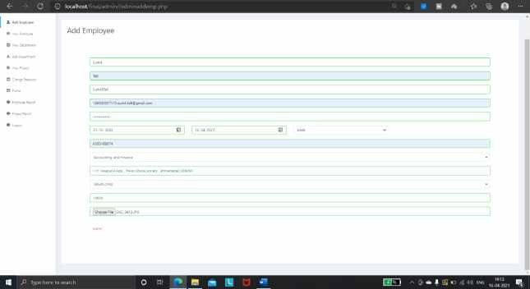

**[Figure : add employee with detail]**

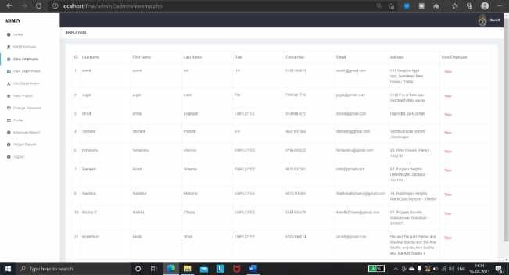

**[Figure : View Employee]**

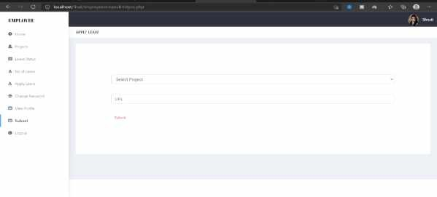

**[Figure : Employee Submitted Work]**

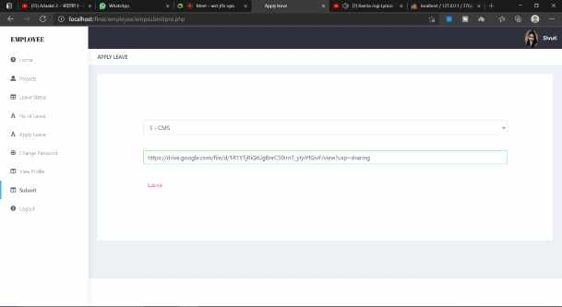

**[Figure : Employee Submitted Work with Details]**

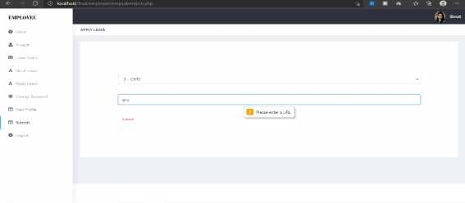

**[Figure : Employee Submitted Work with Validation]**

# CONCLUSION

It was a great experience to design and implement the Employee Management System by using PHP and to work on its documentation. While working on this project we have learned many things especially how to apply the concept of PHP in modelling of real world system. This project is developed using php, html, css, and MySQL fully meets the objective of the system which it has been developed. This project is used for computerizing employee management work in offices etc. The software keeps record of employee’s evaluation, salary etc. The software is capable of easy storage of information related to employee through database.

# BIBLIOGRAPHY

## BOOK REFERENCE

1. PHP and MySQL Web Development, Fifth Edition Authors: Luke Welling and Laura Thomsan Published by : Addison-Wesley Professional in 2016
2. The complete Reference PHP, Eight Edition Author: Steven Holzner Published by: Tata MCGraw-Hill Edition 2008
3. Database Management System, Fifth Edition Author: Dr.Rajiv Chopra Published by: S.Chand & Company

## WEB REFFERENCE

1. W3school

Link: *https://*[*www.w3schools.com/html/html_exercises.asp*](http://www.w3schools.com/html/html_exercises.asp)

1. Coding Infinite

Link: [*https://codinginfinite.com/signup-login-page-php-mysql-databasesource-code/*](https://codinginfinite.com/signup-login-page-php-mysql-database-source-code/)

1. W3school

Link: [*https://www.w3schools.com/html/html_exercises.asp*](https://www.w3schools.com/html/html_exercises.asp)

1. W3resource

Link: <https://w3resource.com/mysql-exercises/>